**Thank (Blame?) Parents for High House Prices**

Last week we went on a quick tour around the world of some of the peculiar or less talked about worries that investors might face today in global markets. The third and final of these – frothy Sydney house prices – doesn’t really fit into camp of issues that receive little airtime, especially in our own backyard. We hear (and feel) over and over about stretched prices across Australia’s capital cities and their likely causes: Chinese buyers, cheap and easy mortgages for owner-occupiers and investors, and self-fulfilling expectations for ever increasing prices. But some recent statistics published by Bloomberg give some credence to the old notion of parents helping their kids as a meaningful driver of a hot property market.

Referencing Digital Finance Analytics estimates, Bloomberg notes “the number of Aussies getting help from their parents has soared to more than half of first-home buyers from just 3 percent six years ago.” Bloomberg continues on to say that “more than two thirds of owners that refinanced houses worth more than A$750,000 did so to extract capital for reasons including helping their kids. Near the start of 2010 the average helping hand from parents was about A$23,000; today, its more than $80,000.”

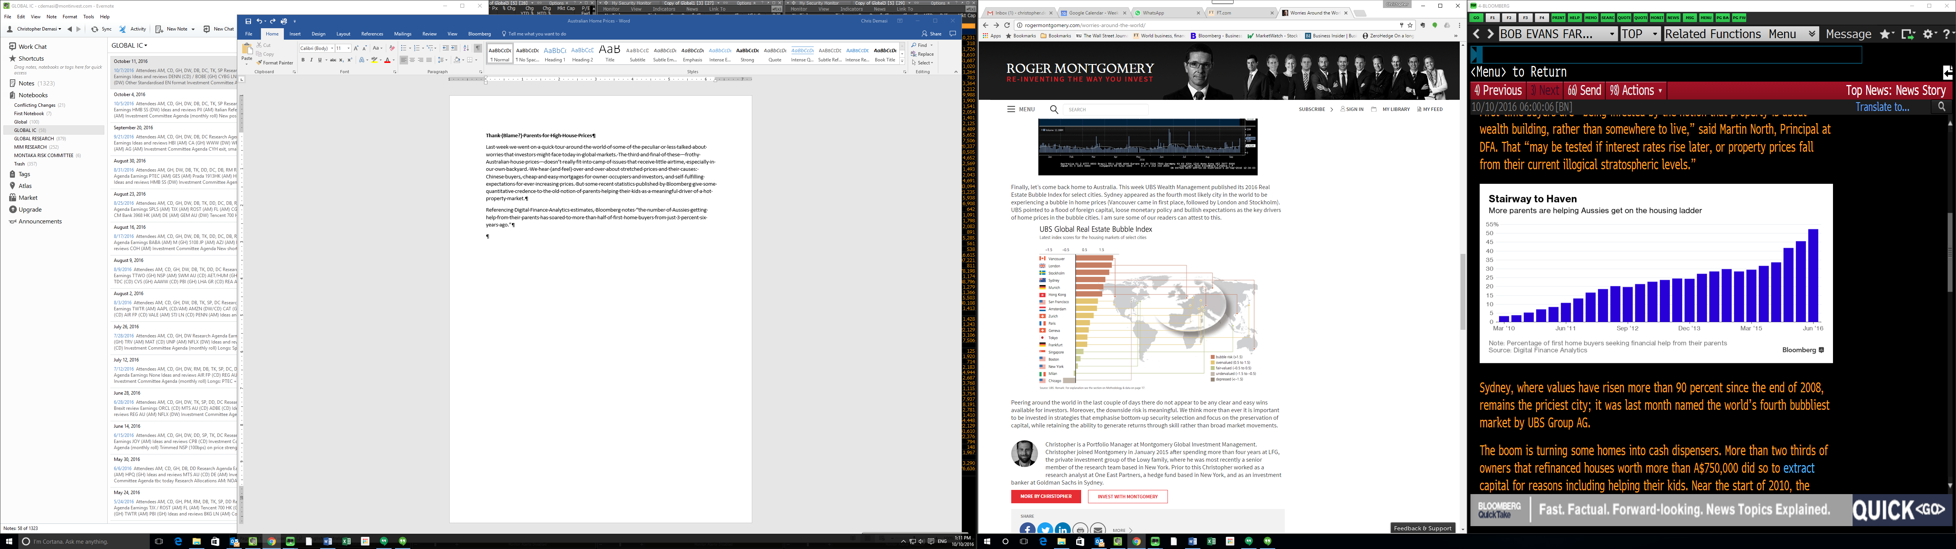

The level of home refinancings also points to home owners using their houses as ATMs. Just over a year ago refinancings made up 16% of all dwellings financed. Today that number is closer to 22%.

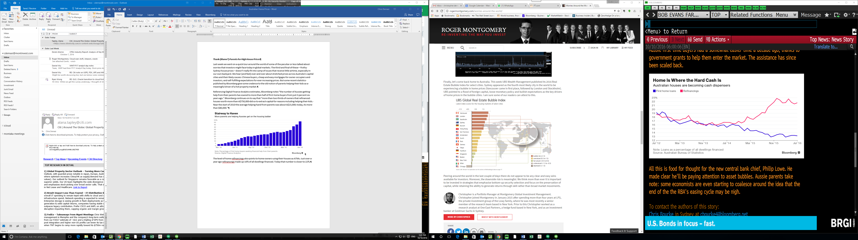

It is interesting, if not concerning, to think of some implications. For example, the next generation are now borrowing to fund the equity component of their home purchase, meaning their leverage is going higher. Not to mention they are being forced to do this as property values go higher, in turn pushing the bank funding requirement AND the parent funding requirement to ever higher dollar levels and multiples of incomes. At the same time, baby boomer mums and dads helping their kids to get a foot in the home market are now perhaps looking at the prospect of living retirement with more leverage themselves. And this is all at a time when interest rates are at record lows which is keeping mortgage repayments down for now.

So next time you wonder how the young couple with 2 kids next door saved the deposit to get the loan for the $850,000 3-bedder a full hour’s drive out of the city, make sure to take a good look at grandma and grandpa when they come over for Sunday BBQ’s. I just hope they’re not expected to bring the sausages as well.