* **Myer owners set for float bonanza**
* **By Online business reporter Michael Janda and staff**
* **Posted Fri Sep 11, 2009 11:10am AEST**
* 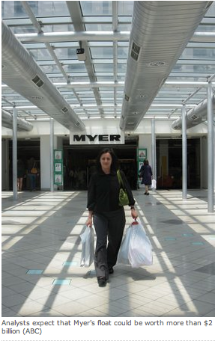
* **The department store Myer has reported a better than expected profit and says it is set to re-list on the Australian Securities Exchange later this year.**
* Myer's net profit for the 12 months to the July 25 was $109 million, an increase of almost 15 per cent on its result the year before.
* The company's before tax earnings were also up by 10.6 per cent to $236 million, but full year sales fell 1.8 per cent compared to last year to $3.26 billion as customers tightened their belts in late 2008 and early this year.
* Myer's chief executive, Bernie Brookes, says the company ended the year well after a difficult first six months of its financial year.
* "The pleasing part for us is that our second half sales were up 0.5 per cent, so we actually had a positive second half. Our full year sales are down 1.8 per cent but, as a lot of you would would recall, we were down 3.7 per cent in the first half, so hence its been a significant and sizeable turnaround," he said.
* Myer expects sales to grow at around 3 per cent over the next year.
* **Private equity success**
* Myer also announced it is launching its initial public offering pre-registration process, which will allow Myer One members and the company's staff to express their interest in receiving a prospectus.
* The company says a prospectus is likely to be lodged on or around Monday September 28, and analysts expect the float to be worth upwards of $2 billion depending on the retail outlook and share market conditions.
* Myer was sold by Coles to US private equity group TPG three years ago for $1.4 billion.
* While most private equity deals in recent times have been more notable for failure than success, share analysts say Myer's owners look like reaping large profits from their three year turnaround of the company.
* Independent share analyst Roger Montgomery says the sale of Myer's Bourke Street store and a major clearance sale shortly after the takeover netted the new owners a combined total of $760 million.
* He says those sales effectively paid for TPG's equity investment in Myer within the first year, leaving just some of the debt the private equity firm used outstanding.
* According to Reuters, Myer's remaining debt was about $650 million in January this year, leaving the private equity owners a potentially massive windfall profit from the float, even after the outstanding debt is repaid.