Tills ring in new king of retailing

* **JAMES KIRBY**
* August 2, 2009

<http://www.theage.com.au/business/tills-ring-in-new-king-of-retailing-20090801-e570.html>

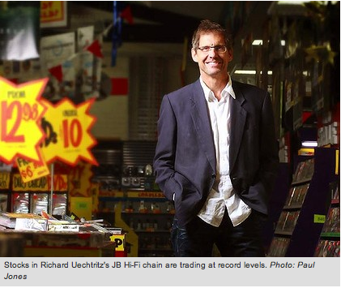

* FOR a generation Harvey Norman’s Gerry Harvey was Australia’s greatest salesman, but the king has lost his crown. You may not know his replacement Richard Uechtritz  by name but you’ll know his company. It’s called JB Hi-Fi.

Touted as a retailing genius since the 1970s, the impish, brilliant billionaire who runs Harvey Norman was never going to give up his title easily. From outsmarting stockbrokers to doing his own radio advertisements to second guessing every other retailer, Gerry Harvey (partner Ian Norman retired years ago) never put a foot wrong. Until now.

Call it hubris, call it a bridge too far, but Harvey finally stepped on a landmine with an ambitious move into Europe.

Unfortunately, he chose Ireland, where the group’s chain of 14 stores was struggling to make money during the past four years.

Now, when it should all be coming right, Ireland has plunged into the worst recession in western Europe, and Harvey Norman’s Irish operation is heading for a $40 million loss, with sales dropping more than 20 per cent.

And Harvey Norman Australia should have been popping champagne corks after the Federal Government’s stimulus package poured money through the doors of every department store. But it’s not working out that way.

As Harvey Norman faced ‘‘sell’’ notes from stockbrokers, JB Hi-Fi stock was trading at record levels last week.

Uechtritz, who is more than a decade younger than his arch-rival, first came to prominence with his Rabbit Photo chain, but it is the JB Hi-Fi chain that has fulfilled his grand ambitions.

There are — inevitably — some similarities between two retailers operating in the same space: both men are strategists with complete power inside their own operations. Both operate far from the bright lights — Uechtritz in an unmarked office in suburban Melbourne, Harvey in a factory warehouse in Homebush, Sydney.

Both created not just a retailing chain but a lifestyle illusion — Harvey Norman is supposed to be cheap and cheerful, though it is often not the cheapest for many goods and services; JB Hi-Fi, with its blackboard prices, is meant to have a ramshackle charm, but it’s actually a stockmarket-listed company, with the folksy touches devised by Uechtritz in head office.

There the similarities fade. Harvey is flamboyant, mischievous, a serious racegoer who lives in relatively modest circumstances. Uechtritz is camera shy, studious, his only obvious indulgence his house. For investors the similarities between the two stocks are fading, too. Among retailing stocks the number that really matters is sales. In the 12 months to June, Harvey Norman franchisees managed sales growth of 7 per cent while JB Hi-Fi was almost four times higher at 26 per cent.

Fund manager Roger Montgomery estimates that Uechtritz’s ability to exploit the original Rudd Government household stimulus package is unrivalled. He says about $500 million of the $12 billion stimulus went straight into the tills at JB Hi-Fi.

For many years Harvey Norman always had the highest rating among the listed retailers — now it’s JB Hi-Fi that commands a premium price earnings ratio, which signals future profit growth.

JB Hi-Fi is trading on a price ratio of 22 times; Harvey Norman is trading on 16 times.

Can Gerry Harvey regain his throne? I don’t think so (and I am a fan; I wrote his biography a few years ago).

The truth is, Uechtritz and JB Hi-Fi are where Harvey Norman was in the mid-1990s. It’s all to play for, and Uechtritz has yet to put a foot wrong.